Quinoa Veggie Burgers + Eating Real Food

*October 26, 2014*

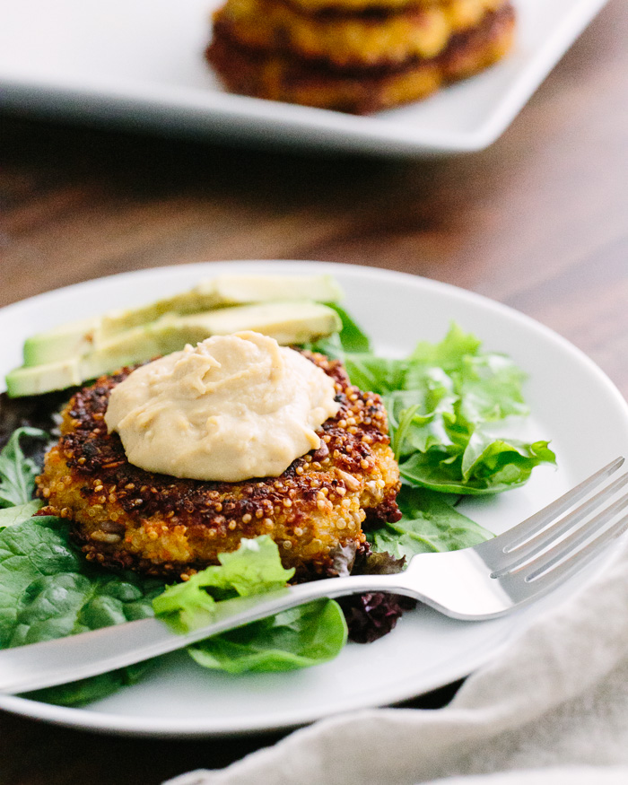

At risk of repetition, I’ll say again something I repeat often: I’m not a natural born cook. Four years ago, I had no idea what quinoa was. Six years ago, I couldn’t even boil a pot of water to make pasta (true story). For my entire childhood, I had little to no interest in cooking food, unless it had chocolate in it.

A change came when Alex and I got married and wanted to have others over for dinner. Our first meal was a bit rough, but luckily our guests were gracious! Gradually, we kept learning and exposing ourselves to people who really, truly *loved* being in the kitchen. It was contagious. A formative moment was when we read a book called [Food Matters](http://www.acouplecooks.com/gift-shop/" \l "books" \t "_blank) that challenged us to consider the way we ate. To make a long story short, we made a commitment to start eating all unprocessed, real foods and started this blog to share about it.

I say all this to introduce Lisa Leake. A mom of two, she had a similar turning point several years ago when she read Michael Pollan’s[In Defense of Food](http://www.acouplecooks.com/gift-shop/" \l "books" \t "_blank),which caused her and her family to take a challenge of eating [real food](http://www.100daysofrealfood.com/real-food-defined-a-k-a-the-rules/" \t "_blank) for 100 days. It changed their lives, and she now chronicles all things real food-related on her immensely popular blog, [100 Days of Real Food](http://www.100daysofrealfood.com/" \t "_blank).

There are a lot of misconceptions when it comes to healthy eating; one I hear often is that you have to be some kind of naturally-talented kitchen god or goddess who’s been cooking since kindergarten. The good news: not true. I think Lisa would agree when I say we’re just normal, everyday people who heard about a different way of eating and started passionately pursuing it. We’re not the best chefs or amazing gourmet masters; we grew up eating Easy Mac instead of kale. But we’ve come to love eating honest, delicious, real foods.

This quinoa veggie burger recipe is from Lisa’s new book, [100 Days of Real Food](http://www.amazon.com/gp/product/0062252550/ref=as_li_tl?ie=UTF8&camp=1789&creative=390957&creativeASIN=0062252550&linkCode=as2&tag=acoco-20&linkId=W6BE4V2A2ZVVIPN5" \t "_blank). We’ve struggled with veggie burgers in the past, but these turned out wonderfully. If you’ve never made veggie burgers or fritters before, it takes a little practice pan-frying them, but it’s worth the learning curve. These turned out moist and flavorful, and stayed nicely in the refrigerator for several days after we made them.

Lisa’s book is full of wonderful recipe ideas; it’s great for families, with a whole section on school lunches, and has options for meat-eaters and vegetarians alike. Check it out if you’re looking to take a small step, a baby step even, towards real food eating. You won’t be disappointed!

Quinoa Veggie Burgers

by: a Couple Cooks

Makes: 8

**What You Need**

* 1 cup uncooked quinoa
* ⅔ cup grated sharp cheddar cheese
* ¾ cup mined carrot (2 to 3 carrots)
* ⅓ cup minced onion
* 3 garlic cloves
* 2 eggs
* ¼ cup whole wheat flour
* ¾ teaspoon ground cumin
* ¾ teaspoon kosher salt
* 3 tablespoons raw sunflower seeds
* 2 tablespoons olive oil
* Hummus
* Sliced avocado
* Salad greens or lettuce leaves

**What To Do**

1. Cook the quinoa, according to [Master Recipe: Perfect Quinoa](http://www.acouplecooks.com/2011/09/master-recipe-perfect-quinoa/" \t "_blank).
2. In the bowl of a food processor, add carrot and chop enough for ¾ cup. Remove and add onion and chop enough for ⅓ cup. Remove and add 3 peeled garlic cloves; process until minced.
3. When the quinoa is done, in a large bowl, thoroughly combine all ingredients except the oil. With wet hands, form the quinoa mixture into 8 patties about 1 inch thick and place on a clean plate or cutting board.
4. In a large sauté pan with a tight-fitting lid, heat the olive oil over medium-low heat. Add the burgers to the pan, cover, and cook until the bottoms are browned, 6 to 8 minutes. (Covering the pan ensures the burgers cook all the way through the middle without overcooking the outside.) Flip the burgers and repeat, adding another tablespoon of oil if necessary (The pan should not be dry). Sauté in a few batches if necessary, and let cool for a few minutes to firm up.
5. Serve warm topped with hummus and avocado and wrapped in big lettuce leaves, or over salad greens.